
JiBE - Office Automation Test Environment Document

Automation Framework

Version 2.0

Modification Log
Version # | Date (MM/DD/CCYY) | Modified By | Change/Update Details
1.0 |  | Manivelrajan | Initial Draft
2.0 | 10/08/2016 | Amit Nandha | Add Screenshot and details descriptions of installation process

Table of Contents

1. Introduction 4
2. System Requirement 5
3. System Installations 6
4. Framework Folder Structure 12

1. Introduction

The automation framework for JiBE - Office has been developed in Eclipse IDE - JAVA using Selenium Webdriver as the automation tool, TestNG framework and Jenkins integration tool.

Eclipse IDE
Eclipse is famous for our Java Integrated Development Environment (IDE), you can easily combine language support and other features into any of our default packages, and the Eclipse Marketplace allows for virtually unlimited customization and extension.

Selenium Webdriver
Selenium Webdriver is part of a suite of tools from the Selenium project which allows one to write and execute automated web application UI tests in any programming language against any HTTP website using any mainstream JavaScript-enabled browser. Selenium Webdriver runs on many different operating systems and can start an instance of different browsers, including Windows Internet Explorer, Mozilla Firefox, and Opera. Using Selenium Webdriver, one can run tests automatically as many times as you want. You can add conditional statements and iteration to tests, which can help if you want to run tests with a set of data.

TestNG
TestNG is a testing framework for Java Programming Language inspired by JUnit and NUnit that provides both a framework that makes writing tests, executing tests and analyzing results easy.

Jenkins
Jenkins is a powerful application that allows continuous integration and continuous delivery of projects, regardless of the platform you are working on.

2. System Requirement

2.1 Hardware requirement (PC configuration)
- Windows 8/10 based PC.
- Ram: 4 GB (minimum)
- HDD: 60 GB or more.
2.2 Software requirement
- Java 8 JRE/JDK (or above)
- Eclipse 4.6 (Neon) / Eclipse 4.5 (Mars)
- Jenkins 2.0
2.3 Browser requirement
Below listed browser are required with latest version.
- Google chrome
- Mozilla Firefox
- Internet explorer

3. System Installations
3.1 Installing JRE or JDK

Step 1: Download JDK
- Go to Java SE download site @ http://www.oracle.com/technetwork/java/javase/downloads/index.html.
- Under "Java Platform, Standard Edition" ⇒ "Java SE 8u{xx}", where {xx} is the latest update number ⇒ Click the "JDK Download" button.
- Check "Accept License Agreement".
- Choose your operating platform, e.g., "Windows x64" (for 64-bit Windows OS) or "Windows x86" (for 32-bit Windows OS). You can check whether your Windows OS is 32-bit or 64-bit via "Control Panel" ⇒ "System" ⇒ Under "System Type".
Step 2: Install JDK and JRE
- Run the downloaded installer (e.g., "jdk-8u{xx}-windows-x64.exe"), which installs both the JDK and JRE. By default, the JDK will be installed in directory "C:\Program Files\Java\jdk1.8.0_xx", where xx denotes the latest upgrade number; and JRE in "C:\Program Files\Java\jre1.8.0_xx".
- For novices, accept the defaults. Follow the screen instructions to install JDK and JRE.
- Check the JDK installed directory by inspecting these folders using File Explorer. Take note of your JDK installed directory, which you will need in the next step.
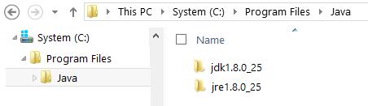
I shall refer to the JDK installed directory as <JAVA_HOME>, hereafter, in this article.
Step 3: Set Java variable environment
Windows OS searches the current directory and the directories listed in the PATH environment variable for executable programs. JDK's programs (such as Java compiler javac.exe and Java runtime java.exe) reside in directory "<JAVA_HOME>\bin" (where <JAVA_HOME> denotes the JDK installed directory). You need to include "<JAVA_HOME>\bin" in the PATH to run the JDK programs.
To edit the PATH environment variable in Windows XP/Vista/7/8/10:
- Launch "Control Panel" ⇒ "System" ⇒ Click "Advanced system settings".
- Switch to "Advanced" tab ⇒ "Environment Variables".
- Under "System Variables", scroll down to select "Path" ⇒ "Edit...”
- (CAUTION: Read this paragraph 3 times before doing this step! There is no UNDO)
For Windows 10: You see a table listing the existing PATH entries. Click "New" ⇒ Enter the JDK's binary directory "c:\Program Files\Java\jdk1.8.0_xx\bin" (Replace xx with your installation's upgrade number!!!) ⇒ Select "Move Up" to move it all the way to the top.
Prior to Windows 10: In "Variable value" field, INSERT "c:\Program Files\Java\jdk1.8.0_xx\bin" (Replace xx with your installation upgrade number!!!) IN FRONT of all the existing directories, followed by a semi-colon (;) which separates the JDK's binary directory from the rest of the existing directories. DO NOT DELETE any existing entries; otherwise, some existing applications may not run.
- Variable name : PATH
Variable value: c:\Program Files\Java\jdk1.8.0_xx\bin;[exiting entries...]

Step 4: Verify the JDK Installation

Open command prompt and type below commands:

- Verify JRE version
Command: java –version
Result: java version "1.8.0_xx"
Java(TM) SE Runtime Environment (build 1.8.0_xx-b13)
Java HotSpot(TM) 64-Bit Server VM (build 25.5-b02, mixed mode)

- Verify JDK version
Command: javac -version
Result: javac 1.8.0_xx

3.2 Setting up Eclipse

Step 1: Download the Eclipse IDE for Java Developers
Download the Eclipse IDE for Java Developers package from the following URL. Ensure that you download the correct version for your Java installation, e.g., 32 bit or 64 bit.
http://www.eclipse.org/downloads

Step 2: Installation the Eclipse IDE

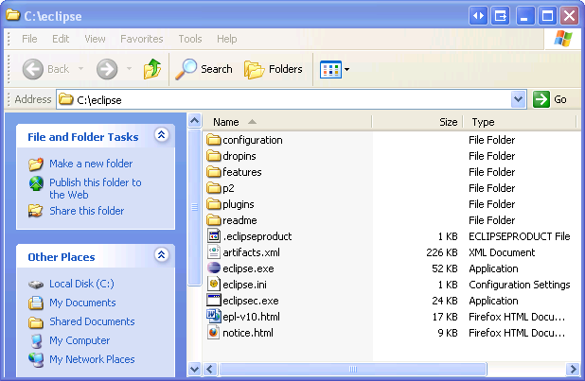
Expand the ZIP file into the root of your hard drive.
When you are done, if your hard drive root is the C:\ drive you will have the following folder on your hard drive:

3.3 Install TestNG in Eclipse

It is easy to install TestNG, as it comes as a plugin for Eclipse IDE. Prerequisite for installing TestNG is your Internet connection should be up & running during installation of this plugin and Eclipse IDE should be installed in your computer.

Steps to follow:

1) Launch the Eclipse IDE and from Help menu, click “Install New Software”.
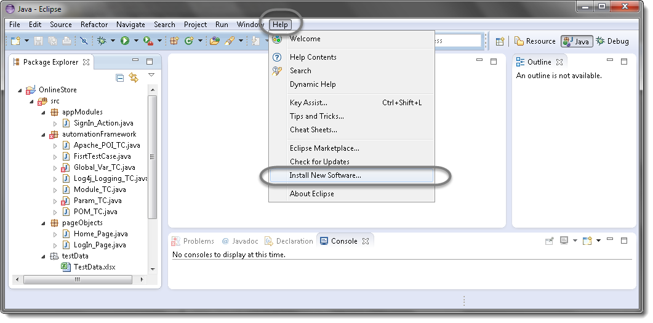

2) You will see a dialog window, click “Add” button.

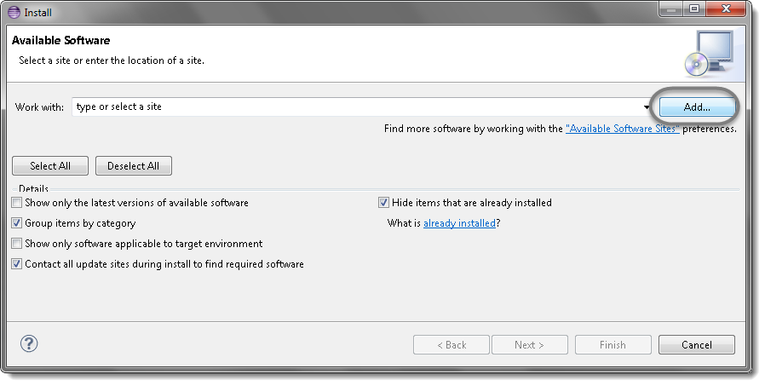.

3) Type name as you wish, let’s take “TestNG” and type “http://beust.com/eclipse/” as location. Click OK.

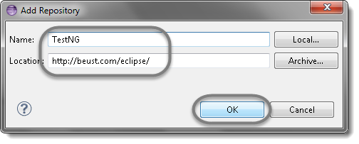

4) You come back to the previous window but this time you must see TestNG option in the available software list. Just Click TestNG and press “Next” button.

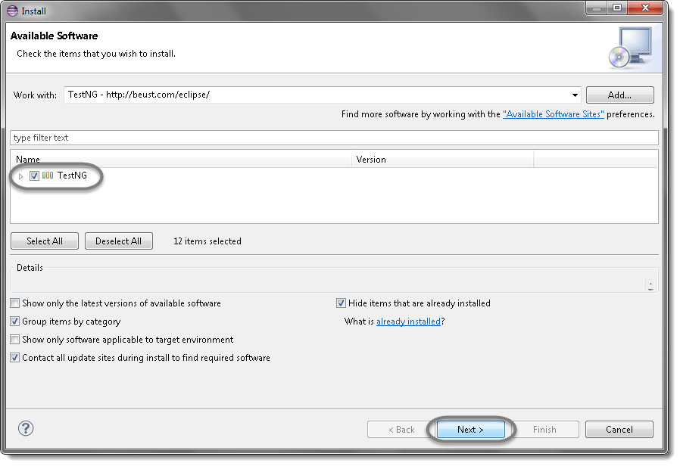

5) Click “I accept the terms of the license agreement” then click Finish.

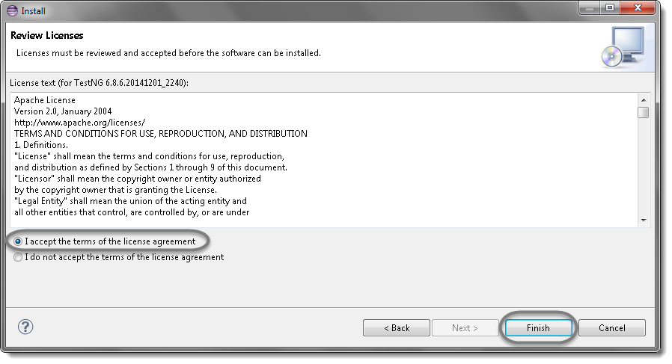
6) You may or may not encounter a Security warning, if in case you do just click OK.

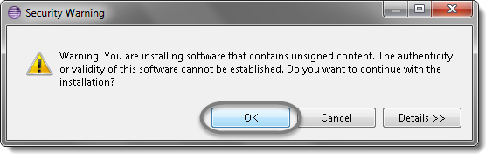
7) Click Next again on the succeeding dialog box until it prompts you to Restart the Eclipse.
8) You are all done now, just Click Yes.
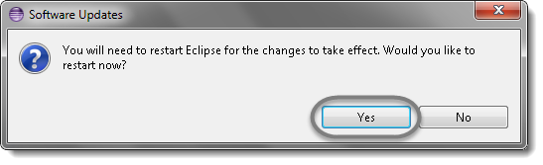
9) Proceed with your workplace.
10) After restart, verify if TestNG was indeed successfully installed. Right click on you project and see if TestNG is displayed in the opened menu.
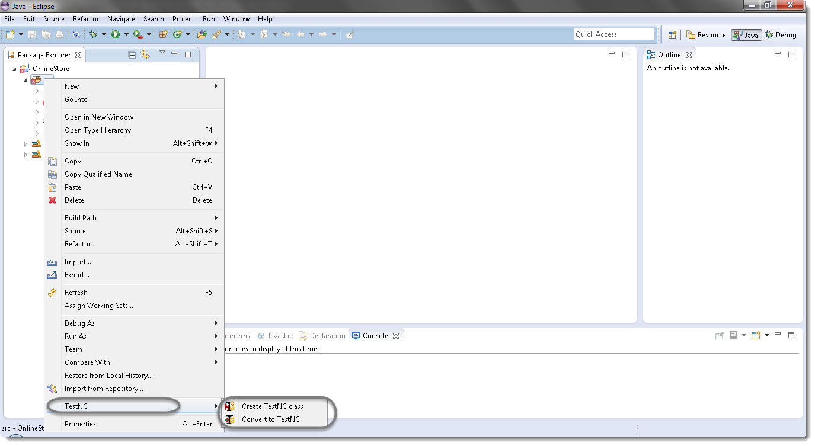

4. Framework Folder Structure

The JiBE - Office Automation Framework comprises of following folder structure –

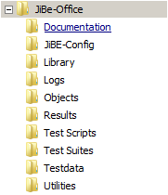
4.1 Documentation
All the documentation related to the “JiBE - Office Automation Framework” is stored within this folder. The document library will be incrementally updated as and when new scripts / functionality are added.
4.2 JiBE-Config
This folder contains files (Excel) with all configurations associated to clients in JiBE - Office
4.3 Library
This folder contains all the library files specific to the automation framework (independent of application under test)
4.4 Logs
This folder contains all the log files related to script execution. Each script file generates a log file during execution which can be used to identify execution success / failure. Screenshots captured during execution for specific scenarios are also stored within the folder.
4.5 Objects
This folder contains the Shared Test Object Repository files (Excel). Each object is identified by a “XPath” which uniquely identifies the object. The mapping of the Object with the corresponding “Xpath” is stored in these files.
4.6 Results
This folder contains the Test Result files that identify whether a Test Script has passed / failed.
4.7 Test Scripts
This folder contains all the Selenium Test Scripts and Methods (Java) files. Each Test Script can be identified as a Test Case.
4.8 Test Suites
This folder contains TestNG Test Suites (XML) files. A test suite is a collection of test cases intended to test a behavior or a set of behaviors of software program. In Test Suites, you can choose the test scripts and the order you wish to execute them.
4.9 Test data
This folder contains the external Test Data source files (Excel). These Test Data files need to be created using pre-defined templates. These test data files are considered as inputs for the script file during execution.
4.10 Utilities
This folder contains utility files like “Delete Logs”, “Delete Results”, and “Delete Screenshots” that can be used for cleanup of archived files within the framework folders.

